**Creational Patterns**

**SINGLETON PATTERN** –

patrón de diseño diseñado para restringir la creación de objetos pertenecientes a una clase o el valor de un tipo a un único objeto (una sola instancia creada en memoria). ANTI-SOLID.

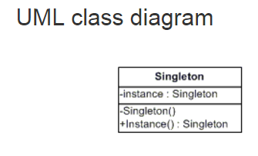

A**BSTRACT_FACTORY PATTERN** –

Creates an instance of several families of clases. Provide an interface for creating families of related or dependent objects without specifying their concrete classes.

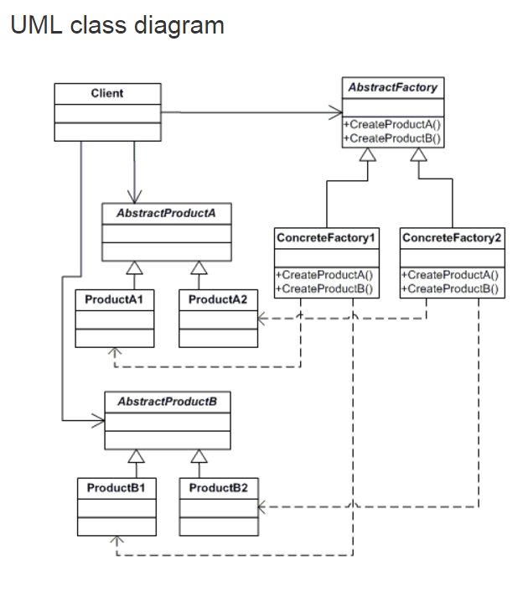

**FACTORY METHOD PATTERN**

Creates an instance of several derived clases. Define an interface for creating an object, but let subclasses decide which class to instantiate. Factory Method lets a class defer instantiation to subclasses.

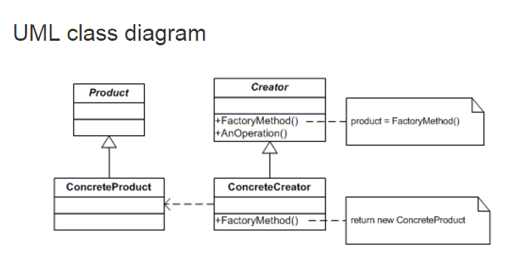

**Structural Patterns**

**BRIDGE PATTERN**

El patrón Bridge, también conocido como Handle/Body, es una técnica usada en programación para desacoplar una abstracción de su implementación, de manera que ambas puedan ser modificadas independientemente sin necesidad de alterar por ello la otra.

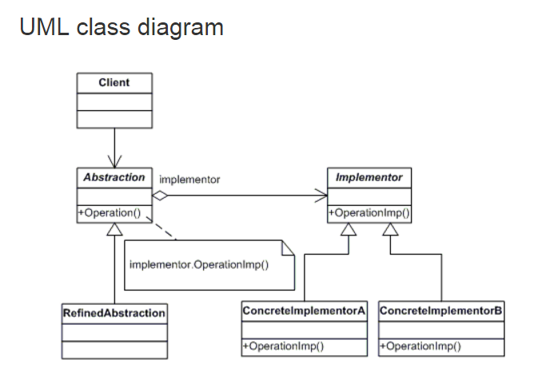

**FACADE PATTERN**

Provide a unified interface to a set of interfaces in a subsystem. Façade defines a higher-level interface that makes the subsystem easier to use.

Ejemplo: Se usa mucho para servicios web; encapsular, en una sola llamada /respuesta desde el cliente, varias llamadas "internas" en el facade a los servicios más pequeños que se necesitan para el response.

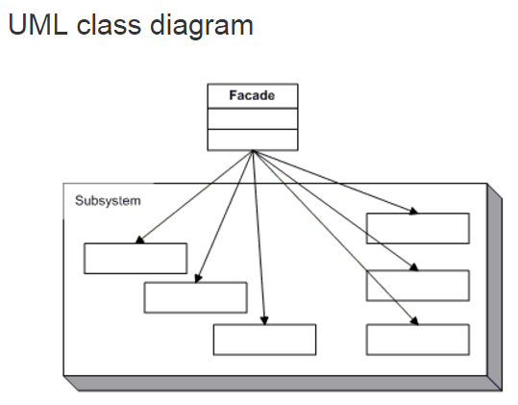

**ADAPTER PATTERN**

Convert the interface of a class into another interface clients expect. Adapter lets classes work together that couldn't otherwise because of incompatible interfaces. These incompatible classes may come from different libraries or frameworks.

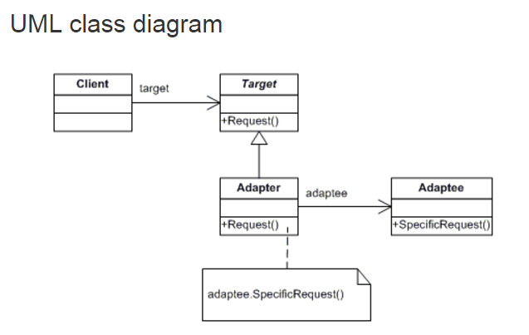

**COMPOSITE PATTERN**

Compose objects into tree structures to represent part-whole hierarchies. Composite lets clients treat individual objects and compositions of objects uniformly.

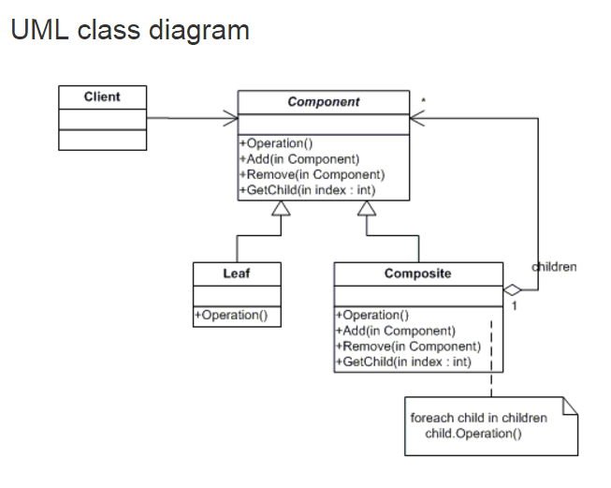

**PROXY**

Provide a surrogate or placeholder for another object to control access to it.

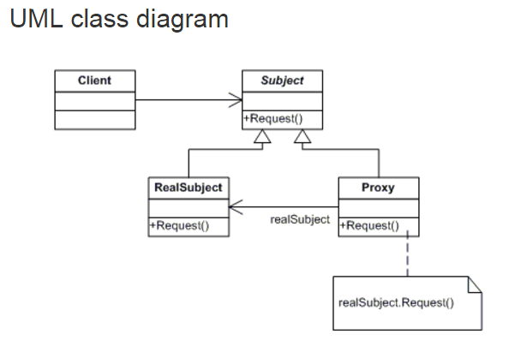

**Behavioral Patterns**

**COMMAND**

Encapsulate a request as an object, thereby letting you parameterize clients with different requests, queue or log requests, and support undoable operations.

The classes and objects participating in this pattern are:

Command - declares an interface for executing an operation

ConcreteCommand - defines a binding between a Receiver object and an action / implements Execute by invoking the corresponding operation(s) on Receiver

Client (Main) - creates a ConcreteCommand object and sets its receiver

Invoker - asks the command to carry out the request

Receiver - knows how to perform the operations associated with carrying out the request.

La intermediación de comando desacopla emisor y receptor

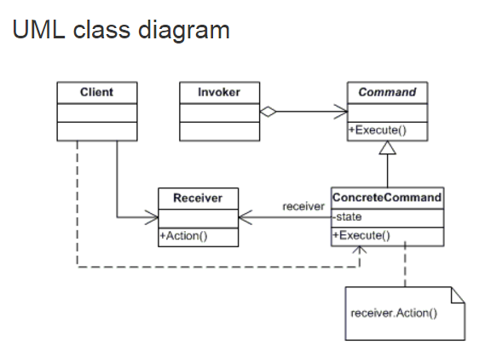

**ITERATOR**

Sequentially access the elements of a Collection. Provide a way to access the elements of an aggregate object sequentially without exposing its underlying representation.

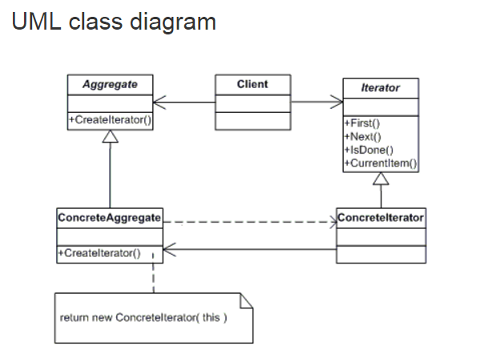

 The classes and objects participating in this pattern are:

* **Iterator**  **(AbstractIterator)**
  + defines an interface for accessing and traversing elements.
* **ConcreteIterator**  **(Iterator)**
  + implements the Iterator interface.
  + keeps track of the current position in the traversal of the aggregate.
* **Aggregate**  **(AbstractCollection)**
  + defines an interface for creating an Iterator object
* **ConcreteAggregate**  **(Collection)**
  + implements the Iterator creation interface to return an instance of the proper ConcreteIterator